C:\Program Files\Microsoft Office\MEDIA\CAGCAT10\j0183290.wmf

School News

### Burton School

Burton, NB

December 1, 2017

December

Newsletter

Student Recognition

C:\Users\denise.watson\AppData\Local\Microsoft\Windows\Temporary Internet Files\Content.IE5\8UPWLZVL\MC900232175[1].wmf

Congratulations to the following students who were recognized during our November assembly for their “bucket filling” behaviour:

Kindergarten: Brady Merrithew

Grade 1: Joseph Persico

Grade 2: Jemma Branscombe

Phys Ed: Adley Ladouceur, Cedric Mason, Evan Layton

Principal’s Choice: Adelaide Chisholm

For December’s assembly we will be having cluster presentations. The assembly will be held on Thursday, December 21st at 11:15 am in the gym.

Our theme for January will be common sense.

Hot Lunch

Please note that we will **not be having hot lunch the first week we return in January.**

Thank you to Melissa Ashburne, Veronique Fournier, Tracy Curtain, Shelley Mason, Mark McMullin, Megan Chisholm and Nicole Pritchett who have helped with our hot lunch program this year. If you would like to assist next year, please call the office and let us know. It is because of these people’s volunteer efforts that we have a hot lunch program!

Dates of Interest

Dec. 7- Skating- King’s Arrow Arena- 9:15-10:00am

Dec. 13th- Rehearse Christmas Play at Lion’s Club at 9:00 am/ turkey dinner at school 11:30 am/ Santa visit in afternoon

Dec 14th- Christmas Play at Burton Lion’s Club at 11:15 am

Dec. 18th- Art Richard Concert at Gesner- 10:45 am

Dec. 21st- Skating- King’s Arrow Arena 9:15-10:15

Dec. 21-Recognition Ceremony at 11:15am

Dec 22th- last day of classes

Jan. 8th- return to classes

#### Art Richard

On Monday, December 18th, we have been invited to Gesner School to watch a performance by Art Richard with them. He is a French singer who always engages the students with his songs and audience participation. We will be leaving the school at 10:15 am and returning by lunch. A permission slip will follow later.

# Gingerbread Houses

The annual tradition of making gingerbread houses will be done on Tuesday, December 19th in the afternoon. All supplies will be provided by the school. As these will be quite fragile, we ask parents to try to pick these up by Thursday of that week. The school is open at 8:00 am to 5:00 pm.

**Turkey Dinner**

On Wednesday, December 13th, we will be serving a turkey lunch for the children. The school will provide all items. Parent volunteers come in first thing in the morning to begin cooking. They will also be preparing the gym so that the whole school can eat together. If this is something you would like to help with, please call the school.

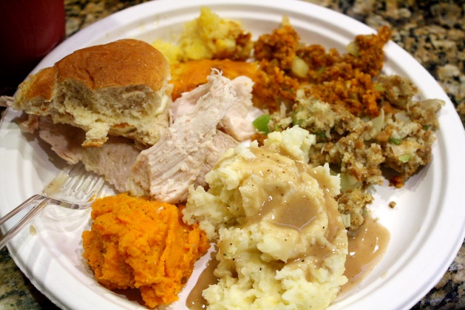

**Santa Visit**

We have arranged for Santa to visit the school around 1:00 pm on Wednesday, December 13th. He will visit the children in the library and each will receive a candy cane**. We also request that parents bring in a wrapped book with their child’s name on it from Santa. You may wish to send it in a bag in your child’s book-bag, bring it to your child’s teacher or drop it off at the office**. We are hoping to be able to take pictures of your child with Santa and prints will be sent home.

C:\Users\denise.watson\AppData\Local\Microsoft\Windows\Temporary Internet Files\Content.IE5\8UPWLZVL\MC900232988[1].wmf

**Christmas Concert**

Our annual Christmas concert will be held at the Burton Lion’s Club at 11:15 am on Thursday, December 14th. The Lion’s Club will be providing hotdogs and milk and the school will have a vegetable tray and cake for after the performance.



Help Needed!

#### There are several areas in which we need parental support this month. If you are available to help with any of the following items, please call the school at 357-4074 and let us know.

Wednesday, December 13th:

* People to cook the potatoes, peas and carrots at the school beginning at approximately 8:30 am.
* People to set up tables and chairs by 11:30 am in the gym as we hope all children will be able to eat together.
* Volunteers to serve the turkey dinner at school at approximately 11:30 am.
* On Thursday morning, Dec. 14th the chairs at the Lion’s Club need to be set up before our performance. We need parents who are able to go for 8:00 am to set up chairs. Many hands make light work. (This year we **do not** require the stage extension to be set up.)

**Principal’s Message**



**December is Caring**

What a great time of the year to focus on caring! Christmas season provides us with natural authentic experiences with which to practice CARING. Modeling the natural “spirit of giving” and good will for our children at this time of the year is invaluable. Every time we purchase or make something for someone, we can make a point of modeling thoughtfulness, ie. “Wow – I bet Aunt Sarah would love this” / “I wonder what Daddy would like most? He loves to read, maybe a sports magazine”. Hopefully the spirit is contagious and our little ones follow our example!

I wish you a happy and safe Christmas season. My hope is that you can enjoy family and friends at this joyous time of the year.

***Merry Christmas!***

Burton School Newsletter Page 2